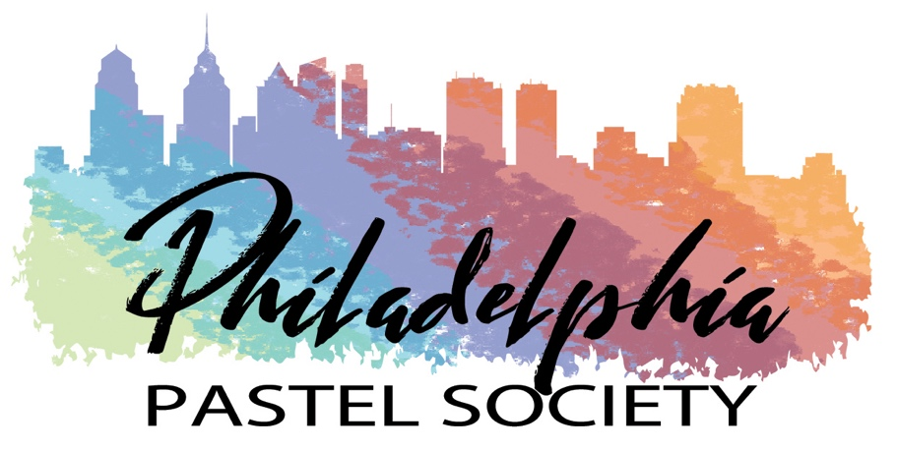

PRESIDENT’S NEWS LETTER - MAY 11, 2021

Greetings to my fellow pastel artists! Spring is finally here and enticing me outdoors to enjoy this gorgeous weather and find inspiration for my next pastel painting. As further encouragement to paint outdoors, Anne Whalon presented a wonderful plein air demo to 15 members in attendance on May 3rd at the Community Art Center. Anne started her painting of the gardens on the side of the building, and was very flexible in dealing with unexpected rain drops and moving her set up indoors to the gallery. Her underpainting was done with an alcohol wash over a light to mid-tone rose pastel. She used India inks and a brayer to block in the darks. Her final painting was gorgeous, with the brilliant red azalea bushes contrasting with the deep violet shadows of the trees in the background and the cool light greens in the foreground. Pictures of her painting process will be posted on our website and social media pages.

My big news is that we have finally put together a PPS Members Directory. It is attached to this email as a PDF document and also as an Excel spreadsheet. The directory is to be shared with members of PPS only, and is provided to help foster communication among our member artists. If you have any additions or corrections to your information, please forward to Pat Riley at philadelphiapastelsociety@gmail.com.

I would also like to remind members about some upcoming events.

PPS Members Exhibition at the Wayne Art Center
Submissions for this show opened on May 1st and will be accepted through July 1st. All PPS member artists can submit up to two paintings, and will be guaranteed acceptance of at least one painting into this show. The show will be juried for awards by Fred Danziger, an accomplished and internationally known Philadelphia area artist. I encourage all of you to take this opportunity to participate in this exhibition at the Wayne Art Center. If you need help in preparing your images for submission, there are very helpful presentations on the PPS website under Exhibitions/Digital Entry Guidelines.

Plein Air Painting Events
Kathy Apfelbaum and Pat Riley have been very busy organizing the schedule of plein air meetups. The next event will be Thursday, May 13th, from 9:30 am – 12:30 pm at Mike Kerr’s Farm in Coatesville. This is a beautiful property and he and his wife have hosted PPS painters there several times now. The plein air committee is working on more venues, including Tyler Arboretum, Chanticleer and Kuerner Farm (near the Brandywine Museum). There will be an end of season picnic and art show again at the Veterans Pavilion at East Goshen Township Park in West Chester. Watch for email announcements about all of these events.

On-line Pastel Exhibition Opportunities
We have been posting on the PPS website opportunities for national juried on-line exhibitions, so please check the website frequently. As of today, submissions are open to shows by the Adirondack Pastel Society, the Pastel Society of Southern California, and the Pastel Society of North Carolina.

I would like to thank all of you for your continued support and commitment to the Philadelphia Pastel Society during this past year. The Board members are hopeful that our event schedule will be returning to normal by the end of the year. Until then, keep painting!

Warm regards,

Blanche Levitt Torphy

Blanche Levitt Torphy
President, Philadelphia Pastel Society

