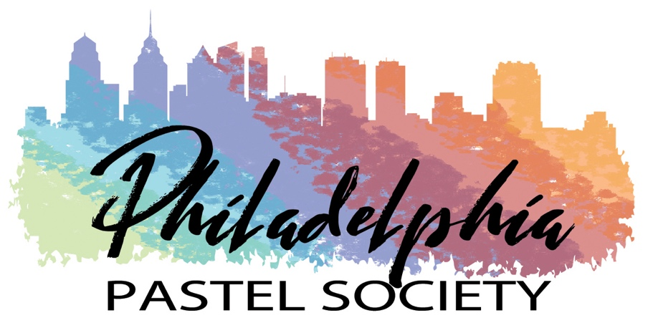

President’s Newsletter – January 11, 2021

Happy New Year everyone! We have a lot of plans for 2021 that I want to share with you.

Saturday, January 16, 2021, 10 am - Noon
General Members Meeting and Demo by Stan Sperlak by Zoom
We are very excited to have a demo by Stan Sperlak that will be presented as a one hour video entitled “Sometimes the Dawn” via Zoom. This demo was pre-recorded at Stan’s studio at the Goshen School of Art at Crow Creek Farm in New Jersey. He will demonstrate how he captures the atmospheric and brilliantly colored sunrise over the marshland and its reflections in the creek. Stan will be available to answer questions at the middle and end of his presentation.

Stan was the juror of awards for our on-line juried show in 2020, and provided insightful commentary on the award-winning paintings. He is a regionally and nationally respected pastel painter, a signature member of the Pastel Society of America, Master Circle pastelist with the International Association or Pastel Societies, and also a Signature member of the Maryland Pastel Society. Stan is the past Director of the Mid Atlantic Plein Air Painters Association, and has been teaching workshops across the country and at his farm near Cape May, NJ. His works have appeared in numerous magazines and books on painting. Stan studied at the Pennsylvania Academy of the Fine Arts and at the Barn Studio of Art in Millville, NJ with Pat Witt.

A link to this Zoom meeting and presentation will be sent to all members by January 14th.

Spring 2021 Plein Air Events
Our plein air painting committee will be working on the spring schedule for plein air venues. The first meetup will be at Ridley Creek State Park at the end of April 2021. Stay tuned for confirmation of the date.

September 12 – October 9, 2021
PPS Members Exhibition at the Wayne Art Center, Ethel Sergeant Clark Smith Gallery
This exhibition will be open to all members of PPS. Artists may submit up to two paintings through EntryThingy, and at least one painting from each artist will be accepted into the show. Al Richards and Blanche Levitt Torphy will co-chair this exhibition. As soon as we have selected a judge of awards, we will be sending out the prospectus. Reminders will be posted on Facebook and Instagram, as well as on our website.

Membership Dues
Thank you to all artists who have renewed their memberships for 2021. We appreciate your support. I want to encourage remaining PPS artists to submit their membership dues by January 30, 2021. Dues of $45 can be paid on line at www.PhiladelphiaPastelSociety.org. Members can also choose to pay by check payable to Philadelphia Pastel Society, and mail to the following address:

PPS Membership Chair
PO Box 741
Bryn Mawr, PA 19010.

PPS Website Members Gallery
We would like to see more images of our members’ works on the PPS website. Mary Rinderle Smith will be reaching out to all of you for pictures of your best paintings. This is an opportunity for you to share your art on the internet, particularly if you don’t have a personal website.

PPS Facebook Group Page
A Facebook group page for PPS members has been created and now has 36 members. It will be a wonderful way for PPS artists to share their work, ideas, and information on upcoming workshops and exhibitions. Check it out and sign up!

I look forward to seeing everyone virtually on January 16th. Until then, enjoy our mild winter days this week, take a long walk and drink in the inspiring views from nature around you. Then bring those moments back to your easel and watch the magic happen!

Warm regards,

Blanche Levitt Torphy
President, Philadelphia Pastel Society

